DHEDHI BROTHERS (CUT TO PACK UNIT)
Date: 16-02-2024
Location: Plot # # 25 / 16, Sector – 12 / C, North Karachi industrial area. Karachi.
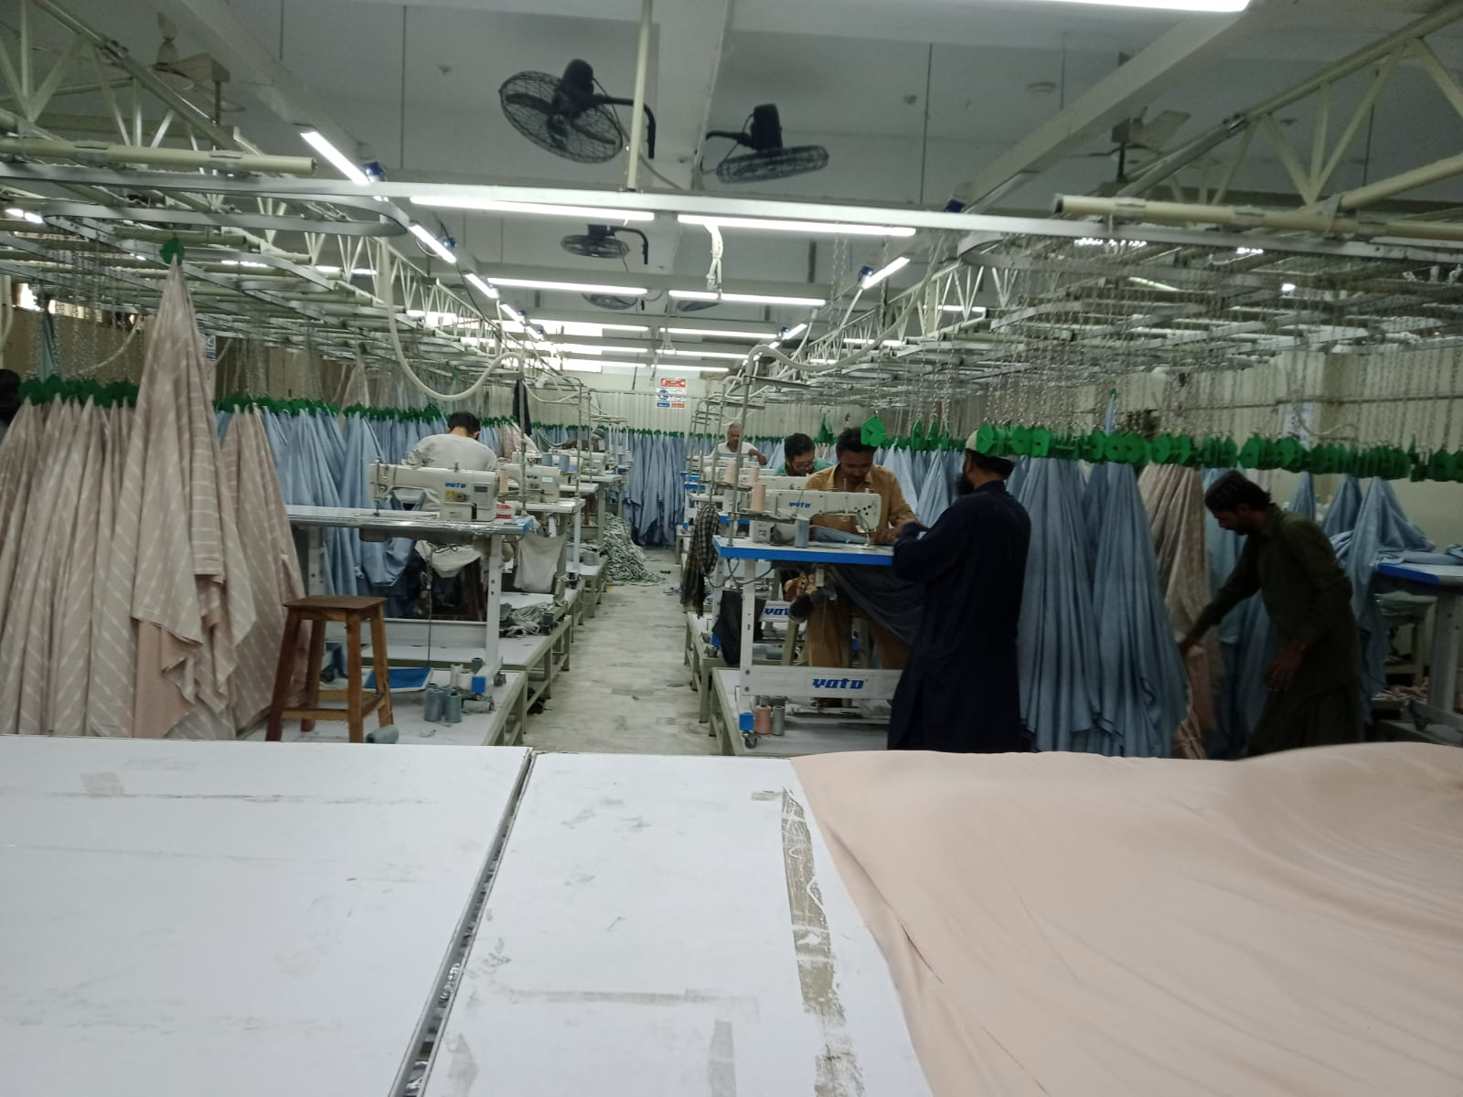

SURVEYED & PREPARED BY: SUBMITTED TO
S.M. Naseem Naqvi. Underwriting Department
Risk Surveyor Salaam Takaful Limited

GENERAL INFORMATION

Address : Plot # 25 / 16, Sector – 12 / C, North Karachi industrial area. Karachi.

Reason for Visit : Pre–Insurance Survey
Survey Date : February 16, 2024
Surveyed By : S.M. Naseem Naqvi
Person (s) Met : Mr. Areeb Anjum Khan (Admin)
Risk Type : Home Textile unit.
Building : 1st & 2nd Class Construction
Rented / Own : Own Premises.
Plot area. : 1000 Square Yards.
Covered area : 9,000 Square Feet.
Operation Timing : General Shifts.
Number of Employee (S) : 250 Employees
Sum Covered : N/A
Annual Turnover : N/A
Risk/ Covered Perils : Fire and Allied Perils

INTRODUCTION
Dhedhi Brothers has a long history of business operations based on highly professional and ethical practices, focused to achieve total customer satisfaction. Dhedhi Brothers, since its inception in 1948, a reliable manufacturer of textile products. Specializing in terry products the company manufacturer and exporter of textiles from Karachi, Pakistan.

Dhedhi Brothers are manufacturing home textile / furnishing: bed Linen, bedsheet sets, duvet / quilt cover sets, towels, bathrobes, kitchen / tea-towels & table linen etc and serving the Retail, Hospitality and Health care industries with a dedicated R&D team. They are importing raw materials and exporting their finished products.

LOCATION AREIAL VIEW

Location: Plot # 27 / 1, Sector – 6 / A, North Karachi industrial area. Karachi.

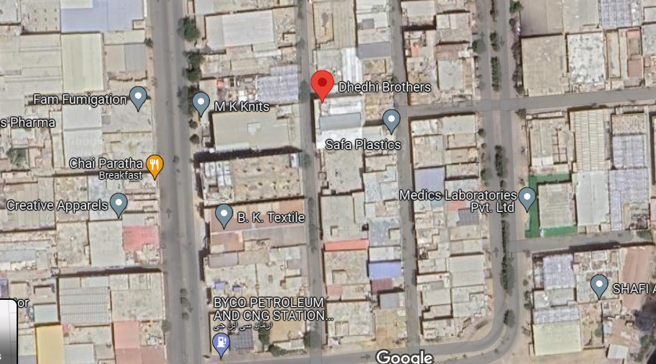
SURROUNDING EXPOSURES
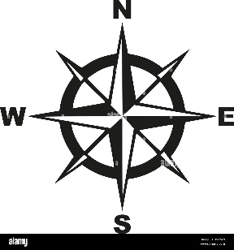
East Auto parts unit.
West Vacant area.
North Vacant plot.
South Road.

MACHINERY
There are sixty stitching machines of different make and models and three cutting machines, and some inspection and packing equipments are available.

BUILDING & CONSTRUCTION
This building has 1st and 2nd class structure (Tin sheet roof). The plot is 1,000 square yards and a covered area is 9,000 square feet. The layout of the site is good, giving access to processing areas from all sides for emergency response. Walls are burnt, silica, or sand lime bricks with 9’ thickness.
The floors are decorated with marble flooring, ventilators having aluminium frame with plain glass and exhaust fans are also fitted in each section. The fire resistance sliding doors not fitted in the premises. The height of the roof is nearly 12 feet high. Floor wise details of the factory is as under:
- Ground Floor:
Cutting, Warehouse, Office section, Bailing machine, Generator room, Water drinking area.

- First Floor:
Staff office, accessories store, Stitching and packing department.

- Second Floor: (Tin Sheet Roof)
Stitching, Cutting, Warehouse, Pray area, Kitchen.

- Roof Top:
Solar Panels.
There is one steel gate fitted at the entrance of the factory premises. Plinth level of the building is above the outside road level and drainage system is made satisfactory for this reason as pect of flooding is low.
UTILITIES

Electricity:
There is one standby generator of PERKINS of 50 KVA capacity found fitted.
Water:
Capacity of Overhead water tank: There is proper cemented overhead tank having capacity of 3000 gallons.

Capacity of underground water tank: The capacity of underground water tank is 12,000 gallons.

HOUSEKEEPING

- The standard of housekeeping in the unit found satisfactory. There is separate warehouse for finished goods and raw materials. In warehouse stocks placed on high iron racks and sufficient distance maintained between the racks. Fabric rolls are placed in stacking position on iron pallets. Finished goods packed ion cardboard cartons and placed in stacking position on floor and stacking height is around six feet.

- Led tube lights and energy saver beams are fitted in processing and storage areas. No loose, hanging wiring seen in these areas. In a few areas conduit electrical wiring was found. There is sufficient distance maintained but in the stitching section due to hanging process there is congestion and space problem exist and walkway are not hurdles free.

- “No Smoking Sign” seen in factory premises including precautionary and preventive measures posters.

- In the cutting section stocks of cut pieces and uncut fabric placed under the cutting tables in big quantity which is very risk practice inviting any fire incidence in these areas.

FIREFIGHTING ARRANGEMENTS.

Public Fire Brigade : Nearest fire brigade station is in the jurisdiction of North Karachi Industrial area which is located at five-minute drive.

Fire Fighting Team : 10 members.

Fire Drill : Half yearly basis (As intimated).

Fire Extinguishers : There are 50 DCP and 01 Co2 hand type fire extinguishers.

Fire Alarm : There are 10 alarm points found.

Fire Buckets : There are 03 stands available.

Smoke Detectors : 32 points found fitted.
Evacuation Plan : Pasted.

SECURITY ARRANGEMENTS

Security Guards : Three-armed security guard deputed in morning and one in night shift deputed.

Security Cameras : There are 28 CCTV cameras found fitted.

Height of Boundary wall: 12 feet.

Barb wire Fence : N / A.

Risk Evaluation
Fire | Medium | Malicious Damage | Medium
Riot & Strike Damage | Low | Explosion | Low
Atmospheric Disturbance | Low | Aircraft Damage | Low
Earthquake, Fire & Shock | Low | Burglary | Low
Vehicle Impact | Medium | Terrorism | Low
Windstorm | Low | Lightning | Low

EMERGRNCY RESPONSE PLAN
The emergency response plan is a plan formulated in advance to ensure fast, orderly, and effective emergency rescue to reduce the damage caused by accidents. An Emergency Response Plan (ERP) is a comprehensive action plan to respond to all emergencies.

EVACUATION PLAN

A good fire evacuation plan for your business will include primary and secondary escape routes. Mark all the exit routes and fire escapes with clear signs. Keep exit routes clear of furniture, equipment, or other objects that could impede a direct means of egress for your employees.

OBSERVATION & RECOMMENDATION
- Considering the size of the factory, hydrant system must be installed. We recommend installing a hydrant system with an electric motor, diesel engine pump and joki pump. Electric and diesel engine pumps must be around 500 GPM capacity and with approximately 10 hydrant points along with hose pipes and nozzles. (Critical)
- Hand type fire extinguishers were found in the unit, but no trolley mounted fire extinguisher of 50 Kg was available in the factory. It is recommended to arrange at least 06 DCP, 03 foam type and 04 Co2 fire trolleys of 50 Kg on priority basis for better protection of the unit. (Critical)
- No barbed wire fence fitted at the boundary wall. It is recommended to install the same for better security of the premises. (Advisory)

- We observed that there is no regular checking of firefighting appliances. It is suggested that a fire protection and prevention checklist should be prepared, and their inspections should be made monthly, and its record maintained. (Advisory)
- We observed that fire resistance sliding door were not fitted in the whole factory. It is recommended to install firefighting sliding doors. (Advisory)
- Standard Operating Procedures (SOPs) like emergency response plans, evacuation plans, preventive maintenance of standby generators and wet fire drill etc. should be maintained and implemented. (Advisory)
- In the stitching department due to hanging bed sheet fabric, there is congestion and blockage creating. It is recommended to arrange more space for removing hurdles. In the department. (Critical)
Risk Rating | Range | Rated | Risk Rating
Storage Condition | 1-5 | 3 | Average
Housekeeping | 1.5 | 3 | Average
Construction | 1.5 | 3 | Average
Fire Protection | 1.5 | 3 | Average
security | 1.5 | 3 | Average
Risk Rating | Rated
Poor | 1
Below Average | 2
Average | 3
Good | 4
Excellent | 5

CONCLUSION

Considering the above referred discussion and observation / recommendation section, in our opinion the risk is rated as “Average”. However, after implementing our recommendations, the risk may be much better.

FOR AND OR BEHALF OF SALAAM TAKAFUL

